To fetch ALTERNATE records from a table. (EVEN NUMBERED)  
select * from emp where rowid in (select decode(mod(rownum,2),0,rowid, null) from emp);  
To select ALTERNATE records from a table. (ODD NUMBERED)  
select * from emp where rowid in (select decode(mod(rownum,2),0,null ,rowid) from emp);  
Find the 3rd MAX salary in the emp table.  
select distinct sal from emp e1 where 3 = (select count(distinct sal) from emp e2 where e1.sal <= e2.sal);  
Find the 3rd MIN salary in the emp table.  
select distinct sal from emp e1 where 3 = (select count(distinct sal) from emp e2where e1.sal >= e2.sal);  
Select FIRST n records from a table.  
select * from emp where rownum <= &n;  
Select LAST n records from a table  
select * from emp minus select * from emp where rownum <= (select count(*) - &n from emp);  
List dept no., Dept name for all the departments in which there are no employees in the department.  
select * from dept where deptno not in (select deptno from emp);  
alternate solution: select * from dept a where not exists (select * from emp b where a.deptno = b.deptno);  
altertnate solution: select empno,ename,b.deptno,dname from emp a, dept b where a.deptno(+) = b.deptno and empno is null;  
How to get 3 Max salaries ?  
select distinct sal from emp a where 3 >= (select count(distinct sal) from emp b where a.sal <= b.sal) order by a.sal desc;  
How to get 3 Min salaries ?  
select distinct sal from emp a where 3 >= (select count(distinct sal) from emp b where a.sal >= b.sal);  
How to get nth max salaries ?  
select distinct hiredate from emp a where &n = (select count(distinct sal) from emp b where a.sal >= b.sal);  
Select DISTINCT RECORDS from emp table.  
select * from emp a where rowid = (select max(rowid) from emp b where a.empno=b.empno);  
How to delete duplicate rows in a table?  
delete from emp a where rowid != (select max(rowid) from emp b where a.empno=b.empno);  
Count of number of employees in department wise.  
select count(EMPNO), b.deptno, dname from emp a, dept b where a.deptno(+)=b.deptno group by b.deptno,dname;  
Suppose there is annual salary information provided by emp table. How to fetch monthly salary of each and every employee?  
  
select ename,sal/12 as monthlysal from emp;  
  
Select all record from emp table where deptno =10 or 40.  
  
select * from emp where deptno=30 or deptno=10;  
  
Select all record from emp table where deptno=30 and sal>1500.  
  
select * from emp where deptno=30 and sal>1500;  
  
Select all record from emp where job not in SALESMAN or CLERK.  
  
select * from emp where job not in ('SALESMAN','CLERK');  
  
Select all record from emp where ename in 'BLAKE','SCOTT','KING'and'FORD'.  
  
select * from emp where ename in('JONES','BLAKE','SCOTT','KING','FORD');  
  
Select all records where ename starts with ‘S’ and its lenth is 6 char.  
  
select * from emp where ename like'S__

Create table Activities (sell_date date, product varchar(20))  
  
insert into Activities (sell_date, product) values ('2020-05-30', 'Headphone')  
insert into Activities (sell_date, product) values ('2020-06-01', 'Pencil')  
insert into Activities (sell_date, product) values ('2020-06-02', 'Mask')  
insert into Activities (sell_date, product) values ('2020-05-30', 'Basketball')  
insert into Activities (sell_date, product) values ('2020-06-01', 'Bible')  
insert into Activities (sell_date, product) values ('2020-06-02', 'Mask')  
insert into Activities (sell_date, product) values ('2020-05-30', 'T-Shirt')  
  
[#sql](https://www.linkedin.com/feed/hashtag/?keywords=sql&highlightedUpdateUrns=urn%3Ali%3Aactivity%3A7027596724437168129) [#dataengineer](https://www.linkedin.com/feed/hashtag/?keywords=dataengineer&highlightedUpdateUrns=urn%3Ali%3Aactivity%3A7027596724437168129) [#adobe](https://www.linkedin.com/feed/hashtag/?keywords=adobe&highlightedUpdateUrns=urn%3Ali%3Aactivity%3A7027596724437168129) [#leetcode](https://www.linkedin.com/feed/hashtag/?keywords=leetcode&highlightedUpdateUrns=urn%3Ali%3Aactivity%3A7027596724437168129)

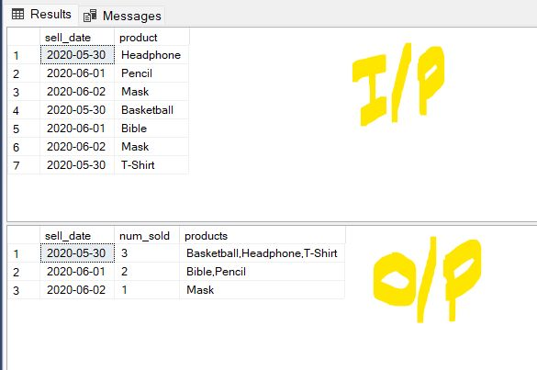

**SELECT SELL_DATE, COUNT(distinct product), LISTAGG(distinct PRODUCT,',') FROM Activities**

**GROUP BY SELL_DATE**